**Background:**

* 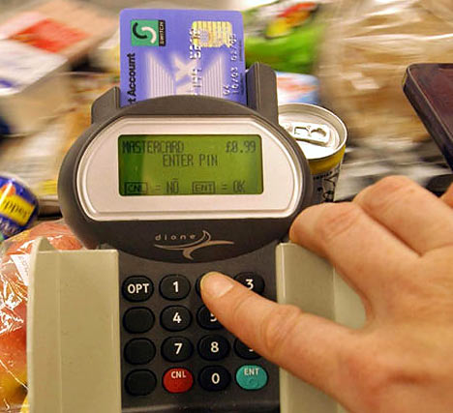PINs (Personal Identification Numbers) are used in a wide   
  range of security applications.
* Four digit PINs (e.g. 1234) are the most common as they are   
  convenient and provide some security. However, six digit PINs   
  (e.g. 123456) should be used whenever possible for improved   
  security.

**Assignment:**

1. Write a simple program that does the following:
   1. Asks the user to enter a 4 digit PIN. This will be the target PIN that the program   
      will try to “crack”.
   2. Runs a loop that starts at 1 and stops when the target PIN is found.

userPin = int(input("Enter your 4 digit pin:"))

count = 1

while (True) :

print ("Your pin is", count)

if (count >= userPin) :

break

else :

count = count + 1

1. Enhance your basic program to include the following code:
   1. The purpose of this code is to measure how long it takes to “crack” the pin.
   2. On average, how long does it take to “crack” a PIN? Try several combinations.

import time

startTime = time.time()

loopCount = 1

while (loopCount <= 1000) :

loopCount = loopCount + 1

endTime = time.time()

print("Elapsed time is:", (endTime - startTime) )

userPin = int(input("Enter your 4 digit pin:"))

count = 1

while (True) :

print ("Your pin is", count)

if (count >= userPin) :

break

else :

count = count + 1

import time

startTime = time.time()

loopCount = 1

while (loopCount <= 1000) :

loopCount = loopCount + 1

endTime = time.time ()

print("Elapsed time is:", (endTime - startTime))

1. Many people use insecure PINs that contain repeated digits such as “1111” or simple sequences such as “1234”.
   1. Enhance your program to try some different digit repeats or digit sequences in order to crack the PIN faster.
   2. Include your enhancements before the main loop.
   3. How does this affect the time needed to “crack” a PIN?
2. import time
3. userPin = int(input("Enter your 4 digit pin: "))
4. startTime = time.time()
5. count = 1
6. check_For = (1111,1234,0000,1212,5555,2000,7777)
7. if (userPin in check_For):
8. print("Your 4 digit pin is ", userPin )
9. else:
10. while count <= userPin :
11. print("Your Pin is",count)
12. count = count + 1
13. endTime = time.time()
14. print("Elapsed time is:", (endTime - startTime) )

1. Explain how the use of a six digit pin would increase security. Refer to some of the things you discovered while writing the programs for this assignment.

A six digit code would have many more possibilities which would make it harder to guess and hack.